**WDD130 W03 Project: Rafting Site - Planning Document**

by Lok Yin Arthur Leung

**Logo**

Selected Logo:

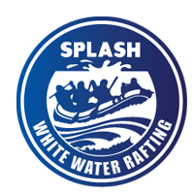

Source: <https://byui-cse.github.io/wdd130-ww-course/resources/wwr-logos-repo.html>

**Colors**

Primary Color: #A0A06A

Secondary Color: #87AFD4

Accent1 Color: #DFDFCD

Accent2 Color: #D2E1EF

**Typography**

Heading Font: Gravitas One (Weights: 400, 700, Black)

Text Font: Merriweather (Weights: 400, 700)

**Coolors URL:**

<https://coolors.co/a0a06a-87afd4-dfdfcd-d2e1ef>